**Assignment Title**: BTEC Level 2 Extended Certificate in ICT – Unit 13: MobileWorldStation Website.

**Introduction:**

In this task, I’m working as a junior web developer for a small company that creates websites for businesses and organisations. I have been asked to investigate two websites; [**thebigphonestore.co.uk**](thebigphonestore.co.uk)and [**bbc.co.uk**](bbc.co.uk)**.** Foreach**,** I will explain the uses, strengths and weakness, and the features of both. I will also be reviewing how the features of both websites could improve Presentation, Usability, Accessibility and Performance.

**Website 1:** bbc.co.uk

REGISTRATIONS & LOGINS

SEARCH BOX

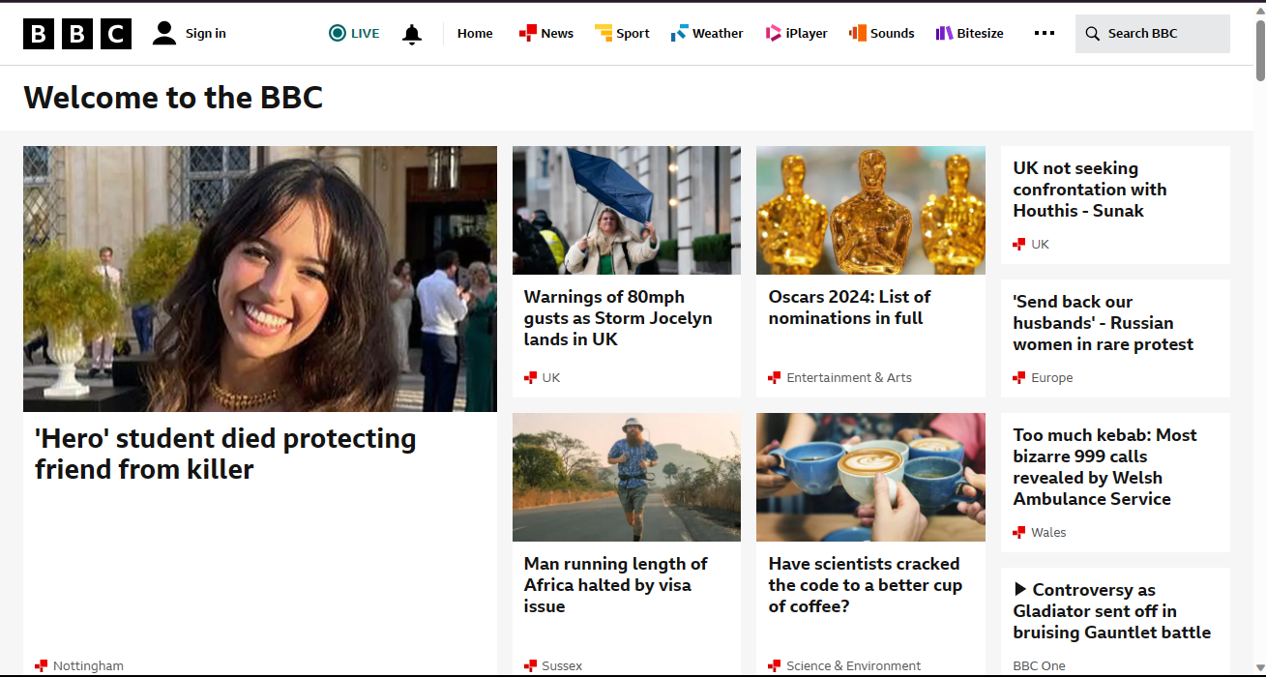

HOTSPOTS

MENUS/HYPERLINKS

**Overview (**Of the Website**):**

The BBC (British Broadcasting Corporation) website main purpose is to inform, entertain and teach the general public. It also provides multimedia and streaming services such as BBC iPlayer, BBC sounds(radio), live TV and broadcast. The BBC website also include additional services such as news information, sports information, weather forecasts, radio/TV and educational resources (**Bitesize**).

**Uses:**

The primary use of this website is to share wide varieties of content such as [News](https://www.bbc.co.uk/news), [Sport](https://www.bbc.co.uk/sport), [Weather](https://www.bbc.co.uk/weather), [iPlayer](https://www.bbc.co.uk/iplayer), [Sounds](https://www.bbc.co.uk/sounds)and [Bitesize](https://www.bbc.co.uk/bitesize). These are easily accessible from the taskbar running across the top of the website.

* News**:**

The most used aspect of the BBC website is the **news** section. This section is responsible for newsgathering and production and it also contains international news coverage, from around the globe (world). Including local (British), international, entertainment, science and political news.

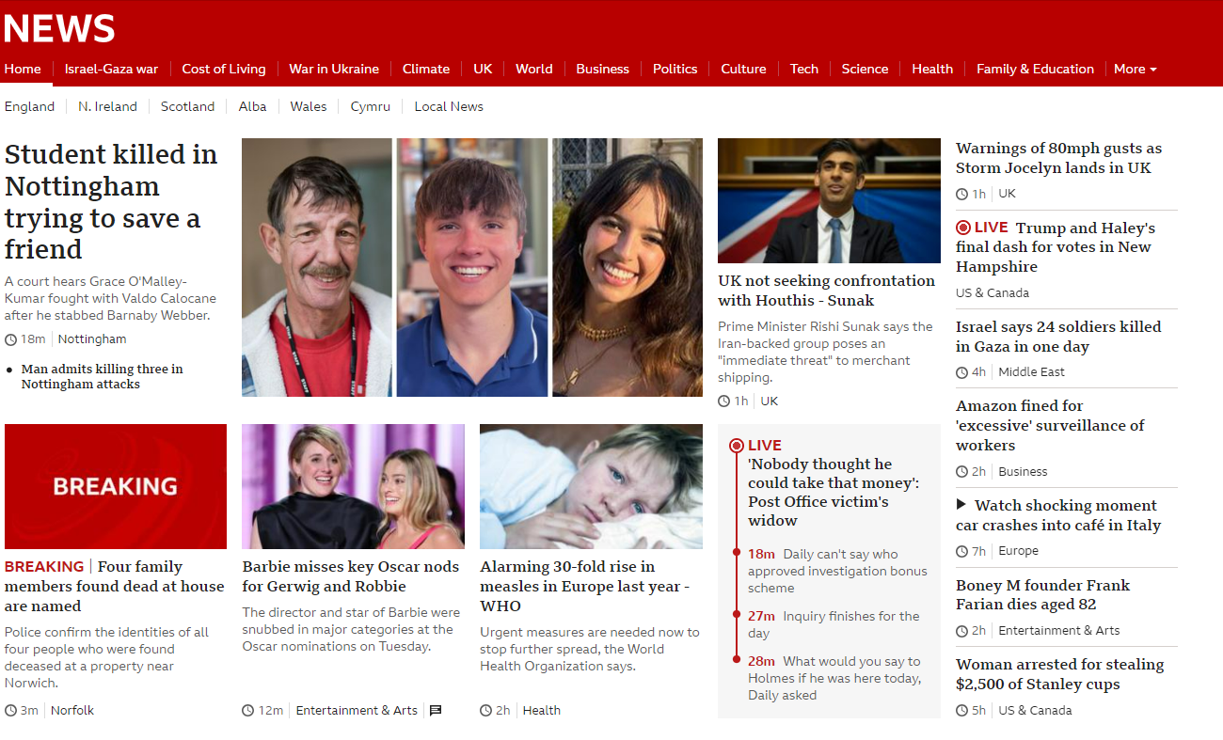

* LearningResources **(Bitesize**):

Another aspect of the BBC website is the educational section which is known as **BITESIZE.** This section contains educational resources that is designed to help both learners and teachers in schoolwork and activities.

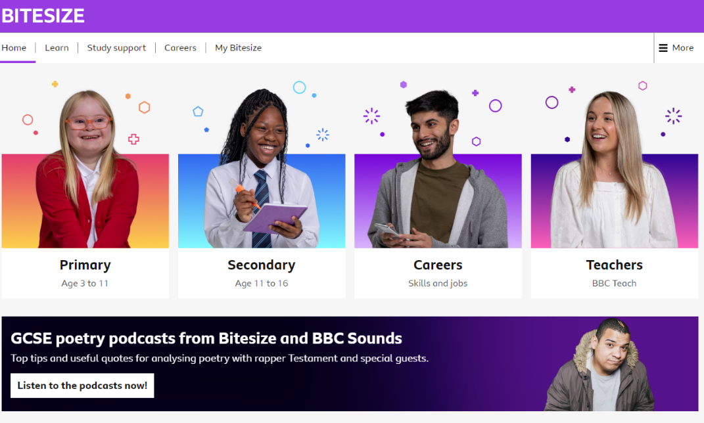

* Multimedia resources (**iPlayer, Sounds**):

The BBC website provides a range of multimedia content such as videos, and radio programs. It usually comes with a subscription, but it allows users to access visual and audio information.

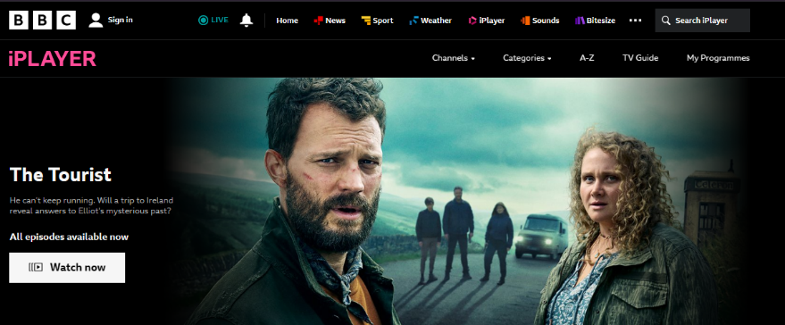

**Features:**

Colour Scheme:

The BBC website uses a colour scheme of black, white, red, yellow, blue and purple gradient. The colours are mainly black and white which serves as the brand’s colour. Although each page on the website has its dedicated colours depending on the area of the website selected by the user. This includes:

* **Homepage**: It has a colour scheme of a white background with black text and the footer having a black background.

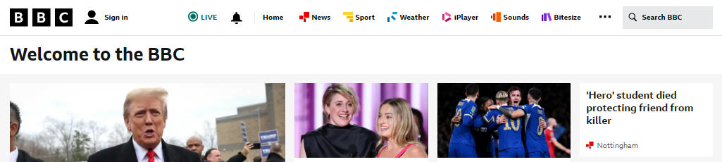

* 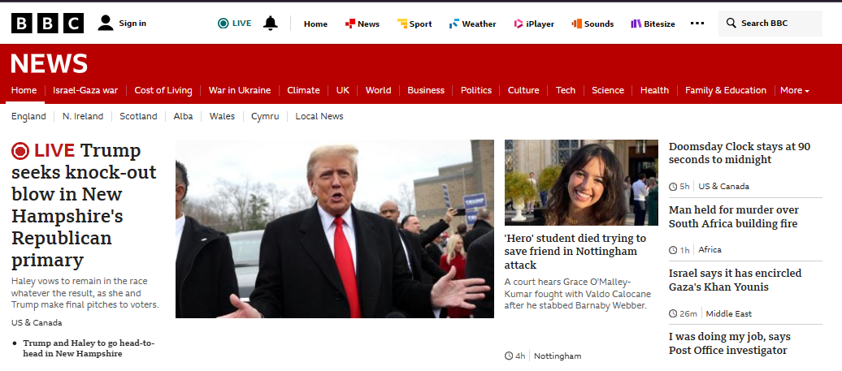**News-page**: It has a colour scheme of a white background with black text, a red heading and the footer having a grey background.
* 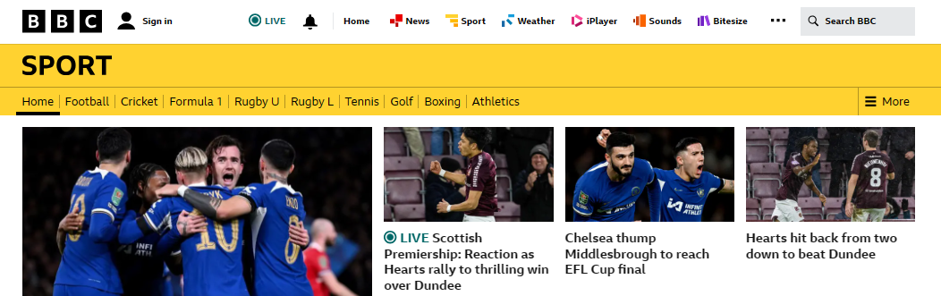**Sport-page**: It has a colour scheme of a white background with black text, a yellow heading and the footer having a black background.
* **Weather-page**: It has a colour scheme of a white background with black text, a blue heading and the footer having a grey background.

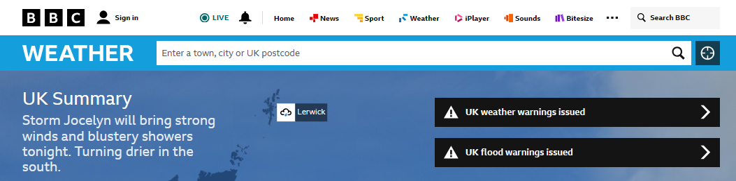

* 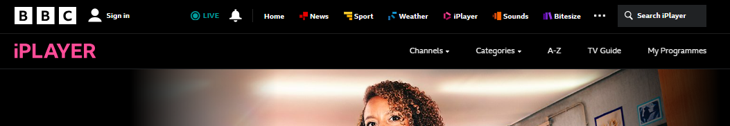**iPlayer-page**: It has a colour scheme of a black background with white text and the footer having a white background.
* 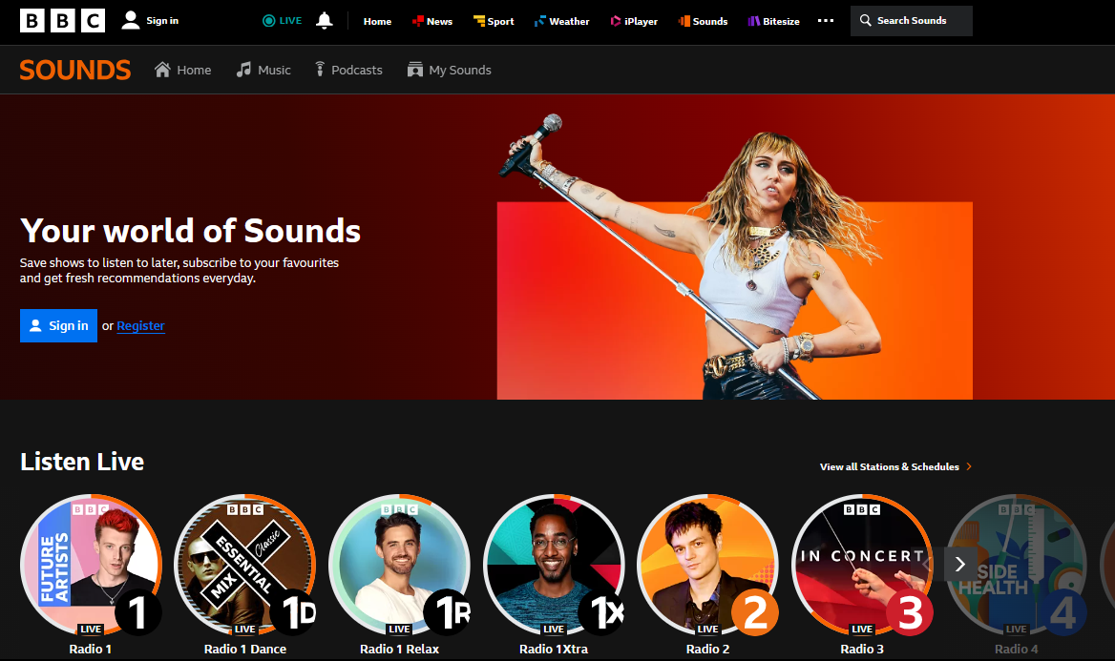**Sounds-page**: It has a colour scheme of a black background with white text and the footer having a black background.
* **Bitesize-page**: It has a colour scheme of a white background with black text, a purple heading and the footer having a black background. It also includes different icons, graphics and images with text of different colours.

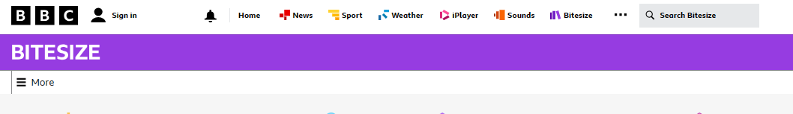

Headline-Bait (**Clickbait**):

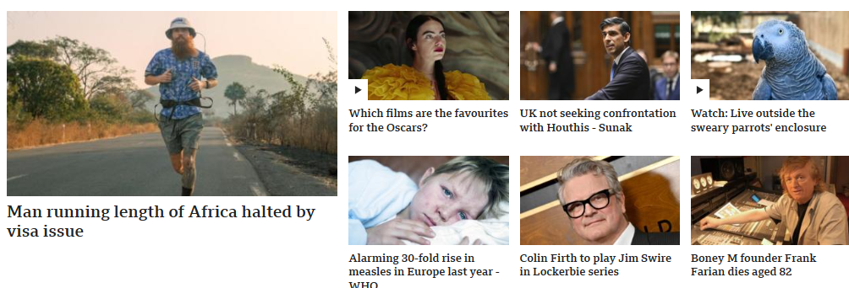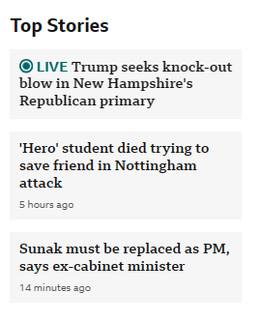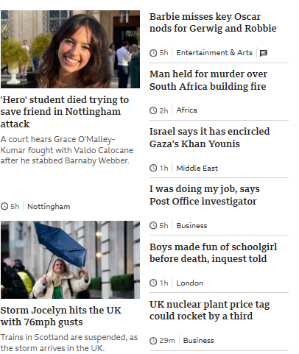The BBC website uses a technique whereby shocking media or images and exceptional headlines are used to attract visitors or users in order to read the news and articles. This technique is usually used by most news website including (the BBC) to increase and generate traffic.

Menus:

The menu bar is situated at the heading of the website. The menu bar contains hyperlinks to other sections or pages of the websites. It helps users or visitors navigate the site and ease access to resourses. The menu is on every page on the website including the footer section, this allows the user to access and navigate every part of the webpage with no issues.



MENUS

Hotspots:

Hotspots also known as ‘**invisible** **links** are spots or medias usually images that acts as hyperlinks on the website that directs you to another page or section when hovered over or clicked on. The hotspots contain text heading that help users recognise and understand them and the images do have good qualities that makes the page look more attractive and interesting. For example: On the BBC website, the images on the news/headline box on the homepage automatically directs to the news page when clicked on.

HOTSPOTS

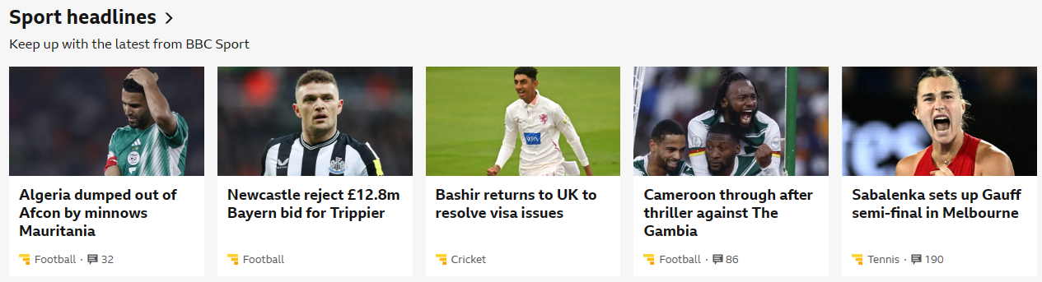

Registrations and Logins:

This feature on the website allows users or visitors to create and access their accounts on the BBC website at any point in time. This feature is located on heading at the top left corner of the homepage and some parts of the website.



Accessibility:

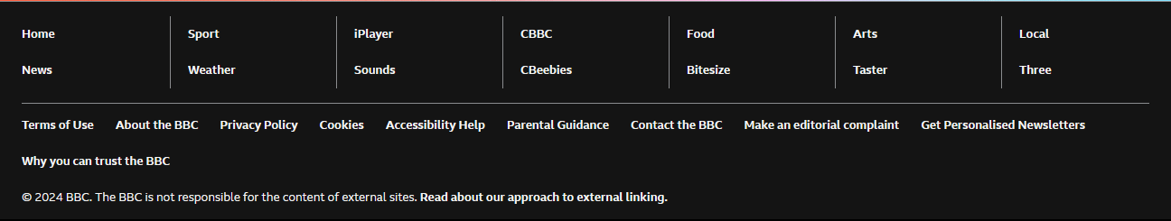This feature helps users to change the BBC website interface to their preferred choice, it is designed to help users or visitors with disabilities and difficulties who have issues navigating and using the website and it also provide articles and advice on how to use this accessibility features. The hyperlink to this feature is located at the footer of the BBC website, it helps users to direct the feature to their specific needs depending on the kind of disability they have.

ACCESSIBILITY HELP

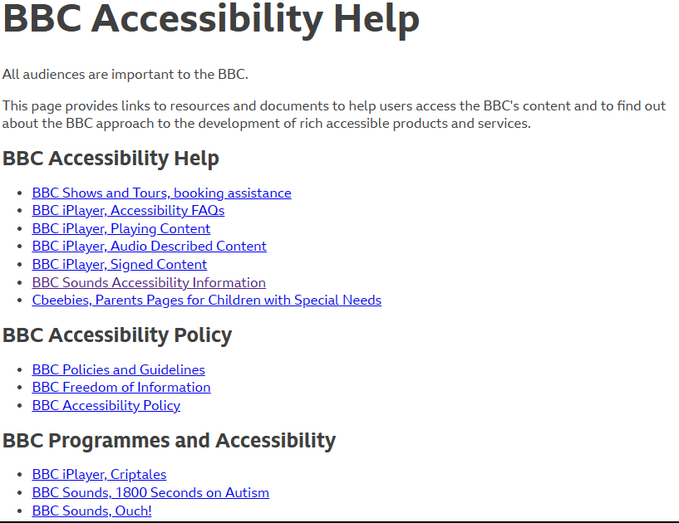

Contact/Support:

This feature allow users to contact customer supports, find information about issues, FAQs, along with how to guides, updates on known issues, details of organisations and more. The hyperlink to this feature is located at the footer of the website.

Contact/Support Section

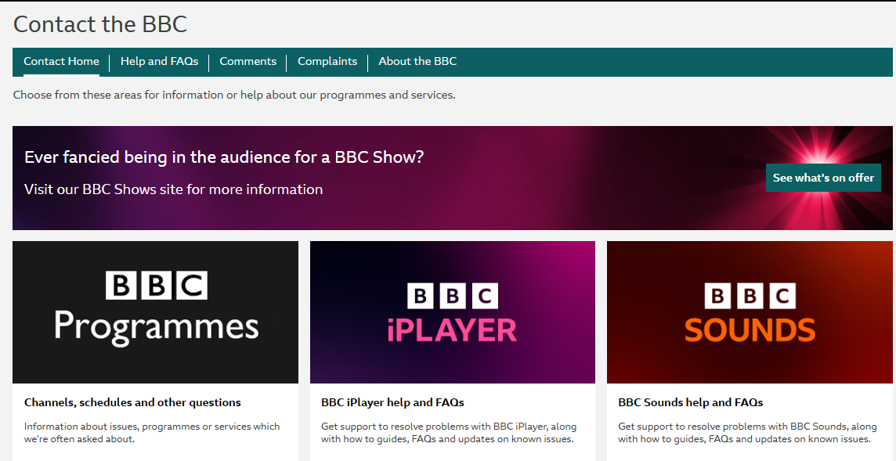

Action Buttons:

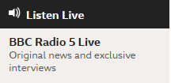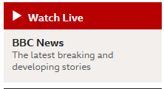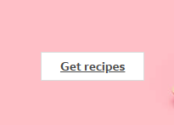Action buttons on the BBC website are levers that help users navigate and perform actions on the website. These buttons are created to be easy to use and identify by the users. Some examples of these action buttons are:

Action Buttons

**Presentation:**

The presentation of the BBC website is very appealing. The white and black colour scheme makes it simple and easy to view because, websites with multiple colours makes it overwhelming and difficult to find information or content, it also causes inconsistency and can lead to slow website causing poor user experience. The white background makes information and news headline presentable to the public while maintaining a clean design. The only disadvantage is that it lacks visual interest which makes some users find the website boring and limited to flexibility of the website design.

**Usability Review:**

From a user’s perspective the website navigation features such as the action buttons, hyperlinks/menus across the heading and footer of each page or section showcases the simplicity of the design and layout of the BBC website. The navigation features allow the users to control what they can see and section of the website they have access to. The simplicity of the website makes it accessible to everyone including people with limited digital or computer knowledge. The BBC website supports cross-platform compatibility and responsiveness, this means it can be accessed across different devices such as mobile phones, tablets, laptops and desktops.

**Accessibility:**

The BBC website has designed the website to make sure that the pages and sections are accessible to users with disabilities and difficulties. The website has an accessibility link that helps users with disabilities to be able to navigate the pages and its content. The accessibility link is at the footer of each page, when clicked by the user it’s directs them to an external link depending on the support/disability. It contains guides and tools that describes how to modify the settings on their device to change the websites interface to their preferred choice. Some of these features they can have access to include:

* Access to audio description options and subtitles on videos, sign language interpreters, captions on videos (for users with hearing aids or hearing difficulties and problems)
* Access to change the font size/colours and access to the text to speech and screen reading features, contrast and brightness (to help users with visual impairments, eye problems, colour blindness, and reading difficulties).
* 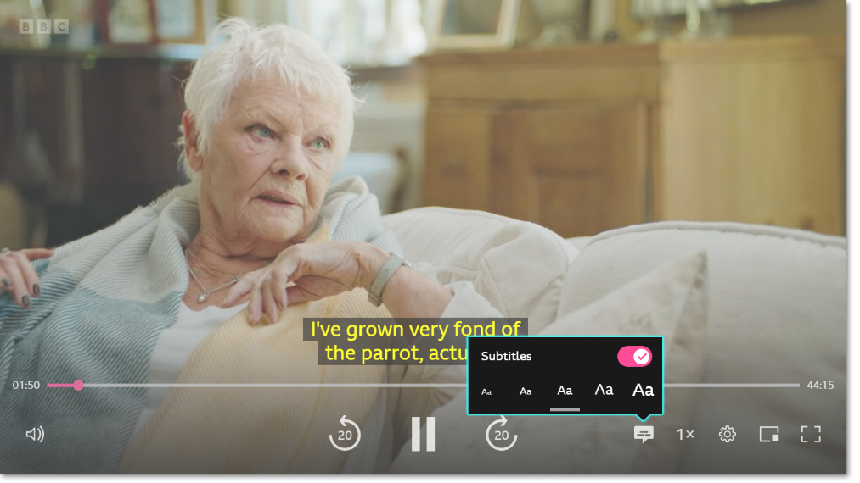Access to translation options for users in different countries/regions (users who do not speak and understand English).

Video Captions

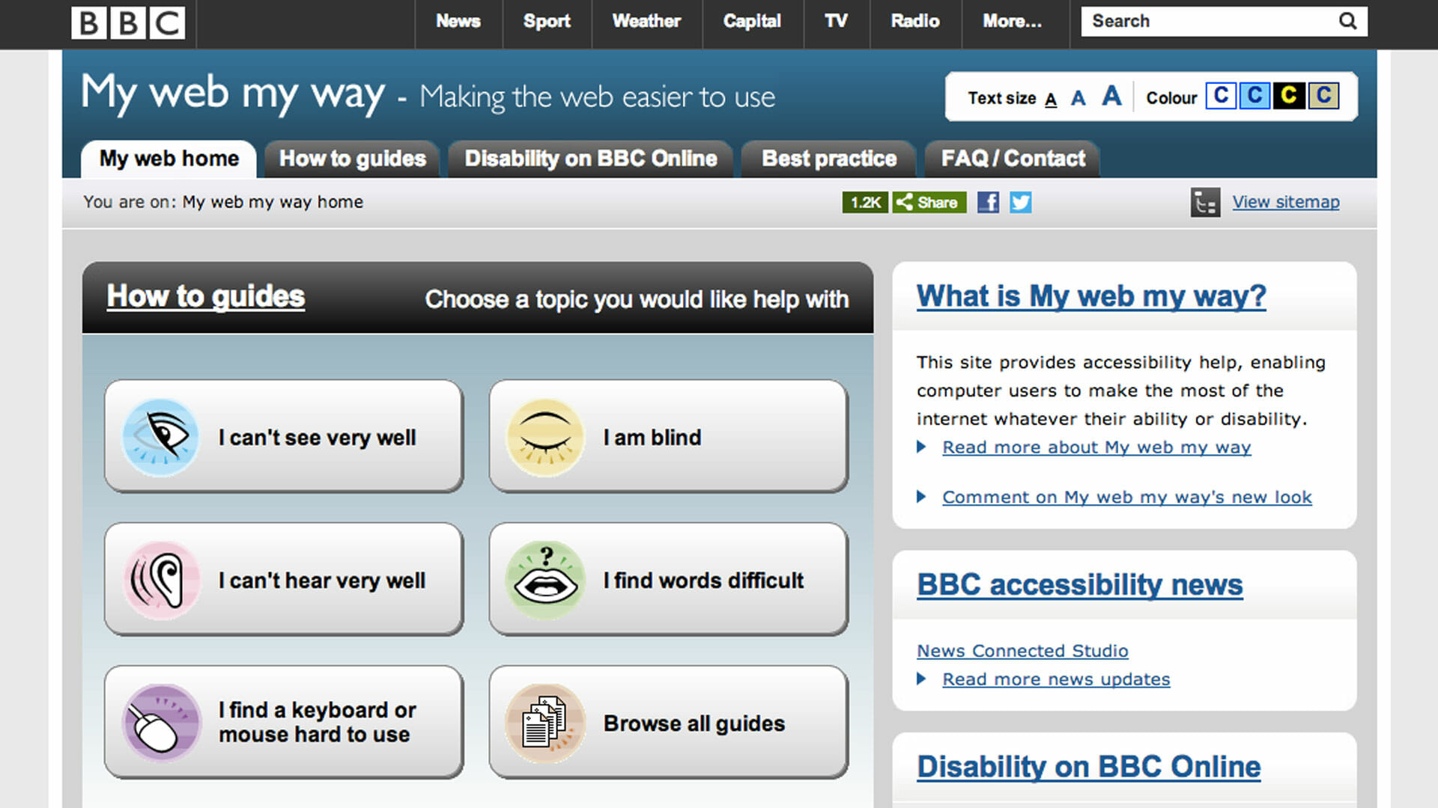

Subtitles

Accessibility Features

**Performance:**

The performance of the BBC website can be determined in a user’s web browser. Based on my research, the performance chart can be determined on a user’s web browser by clicking on ‘**F12**’ to enter the ‘**developer tools**’, then navigate over to the performance bar and click ‘**Ctrl + E**’ to record it. The average total frame performance time in milliseconds of a website is ‘**300ms**’and the frame performance of the BBC website is ‘**8501ms**’. This showcases that the BBC website is very fast, and this improves the user experience and usability of the website.

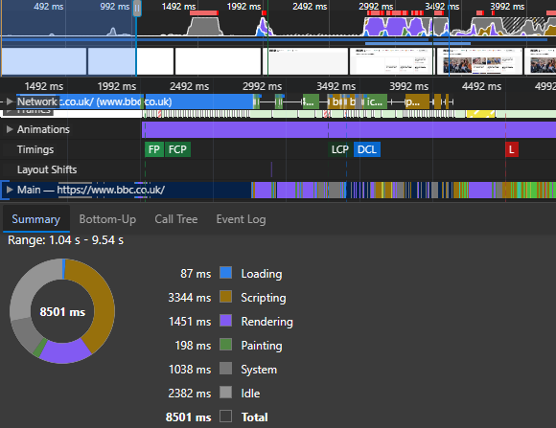

**Strengths:**

The BBC website is very easy to navigate the menus are easy to access and all the action buttons and hyperlinks are working. The site has a well-structured layout that’s clear and well defined with no grammatical error. This makes the content on each page easier to see and read. The website also provides a wide variety of content that allow users to get resources in a single place. These contents provided are verified information, accurate and of great quality relevant to headlines and articles on the pages.

Another strength of the BBC website is the accessibility feature. The website provides certain features and helpful links for users with disabilities/difficulties making the site accessible to everyone. The website also provides cross platform compatibility that is, it allows users to access the website across multiple devices such as mobile phones, tablets, laptops and desktops.

**Weakness:**

The BBC website have some weaknesses that should be removed or improved. The BBC website design and layout is very simple and plain, which makes the website homepage look dull and unattractive to users or visitors. The site also contains advertisements and promotions in some regions which makes it a tool of distraction and annoying in some cases. Some regions and countries are restricted to access the BBC website and its resources making it difficult for foreign users. Every digital or technology-based tool such as a website would have some technical issues in one way or the order which can affect users and their experience on the website.

**Conclusion:**

Based on my report I think the BBC website is a great way to improve the online presence of the British Broadcasting Corporation. It’s also a great action step as it provides ease of access to a wide variety of information to everyone at any time across multiple devices and there’re aspect of the website that can always be improved.